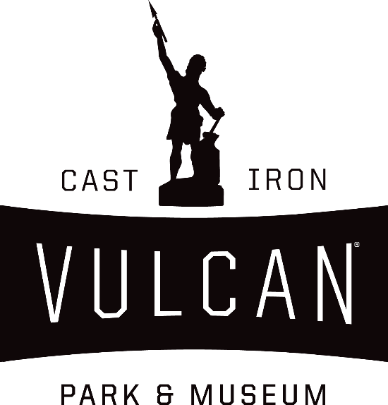

Traveling Trunk Teacher’s Guide
“The People”

Artifact Guide
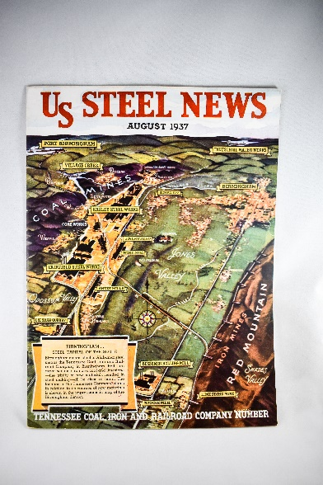
"US Steel News" Company Magazine
Founded in 1901 with the combination of 10 different steel manufacturers around the country, U.S. Steel dominated the steel market in the first half of the 20th century. U.S. Steel gained control of the Birmingham steel industry in 1907 when it gained controlling interest in the Tennessee Coal, Iron, and Railroad Company (TCI). At its peak during World War II, U.S. Steel employed more than 45,000 workers in the Birmingham district.

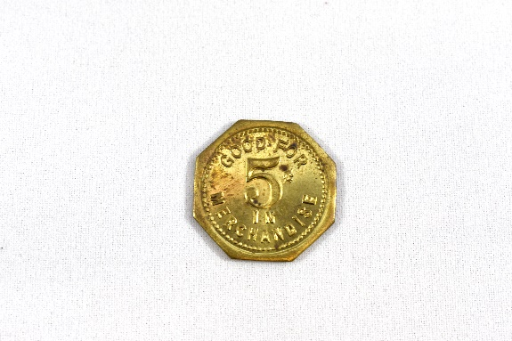
Clacker/Scrip
Clacker, or scrip, was sometimes used as payment by large industries in lieu of real money. It could be used at the company store, but nowhere else, thus leaving workers vulnerable to price hikes, lack of variety, and debt to the company, creating forced company loyalty.

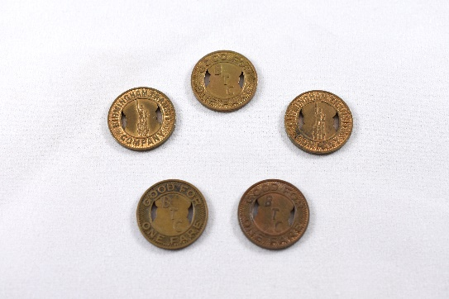
Transit Coins
The Birmingham Transit Company was the successor to the transportation division of the Birmingham Railway & Electric Company. The company helped modernize the transportation system in Birmingham when it oversaw the transition from streetcars to buses in the 1950’s. The availability of reliable transportation attracted new people to the city and helped fuel the growth of Birmingham.

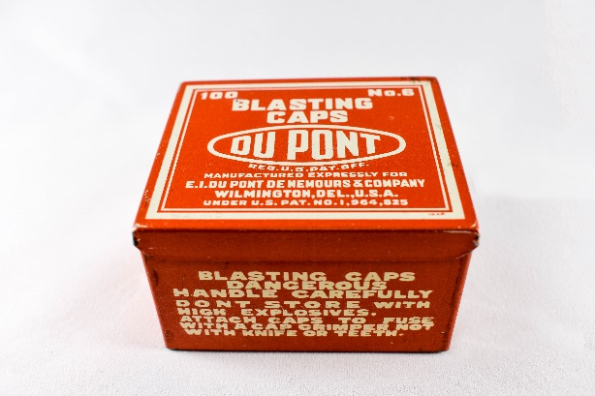
Blasting Caps Box
Also called detonators, blasting caps were used in mining operations to initiate the detonation of explosives in order to expose new areas of natural resources underground. The Dupont Company was founded in 1802 to produce black powder and other explosives, which was the company’s primary focus until the 20th century when it expanded to producing chemicals as well.

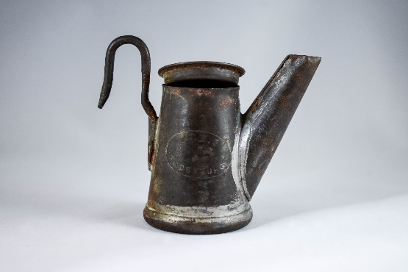
Oil-Wick Lamp
Typically made of brass, this type of lamp would hook onto the front of a miners cap. It would contain a mixture of fat and oil for fuel which would be pulled through the wick to the top of the spout where the lamp would be lit. Open flame lights were extremely dangerous in mines, as they could easily ignite flammable gasses in mines resulting in deadly explosions. Oil-wink lamps were phased out of use by the 1920’s when they were replaced by carbide lamps.

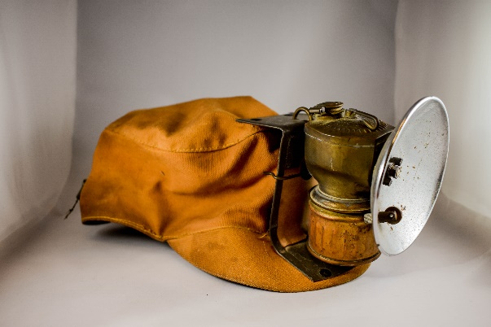
Cloth Mining Hat with Lamp Attached
This type of mining hat was worn prior to the 1920’s in order to hold an open flame lamp. Attached is a carbide lamp with a reflector. Carbide lamps were powered by the reaction of calcium carbide and water. This reaction produces acetylene gas, which burns a clean, white flame. Carbide lamps were predominantly used between 1900 and 1930.

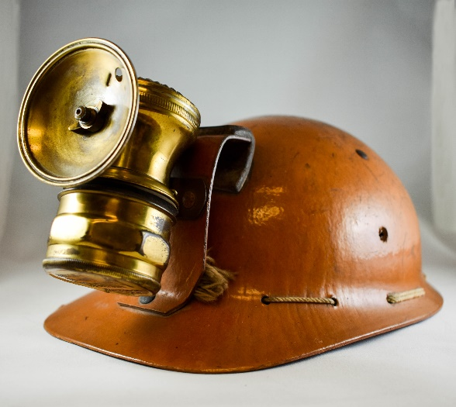
Bakelite Plastic Hard Hat
This type of helmet was first manufactured by the Mine Safety Appliances Company of Pittsburg, PA in 1930. Made of Bakelite plastic with a leather and metal lamp bracket, holding an Auto Lite carbide mining lamp.

If you would like, show your students the following video that demonstrates how a carbide lamp worked: https://www.youtube.com/watch?v=pyFTijbsZzo

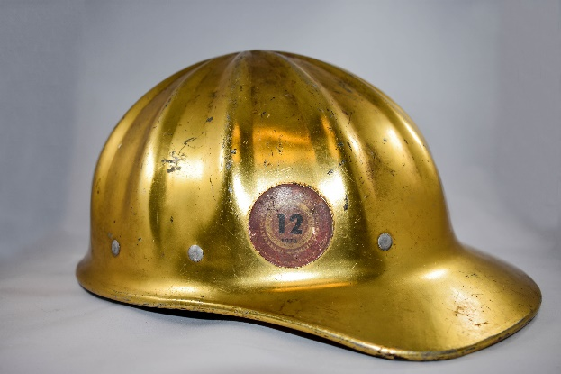
Aluminum Hardhat
The aluminum hardhat was first developed in 1938 by the Bullard Company. This type of hat was used in the steel industry in the mid 1900’s to protect workers from falling objects, or other blunt force trauma.

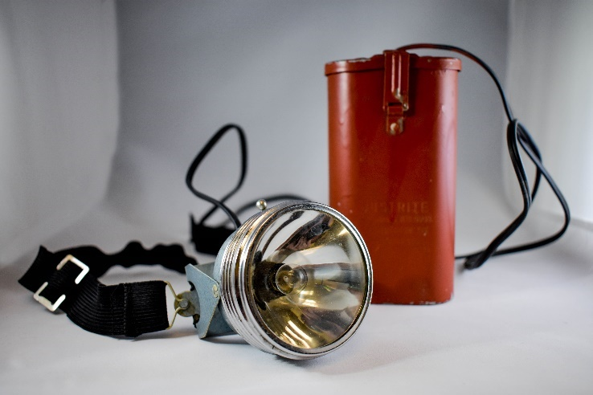
Electric Mining Light
Designed by Thomas Edison for the Mine Safety Appliances Company, battery powered mining lamps were first approved for use in 1915. Batteries were encased in a metal, self-locking case worn on the miner’s belt. The cord would travel up to the cap lamp. The batteries could power the lamp for up to 12 hours, and were rechargeable.

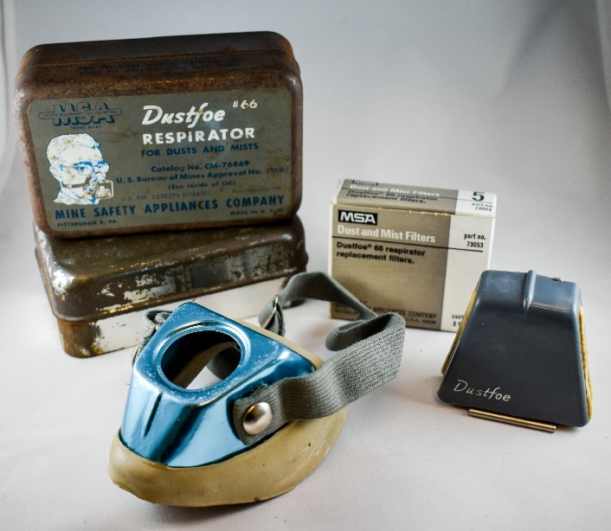

"Dust Foe" Respirator
Originally patented by H.B. Lewis in 1936, this type of respirator was approved by the Mining Safety Appliances Company to filter out certain dangerous dusts and mists. The respirator was improved upon and an updated patent was filed in 1952 for the version you see here.

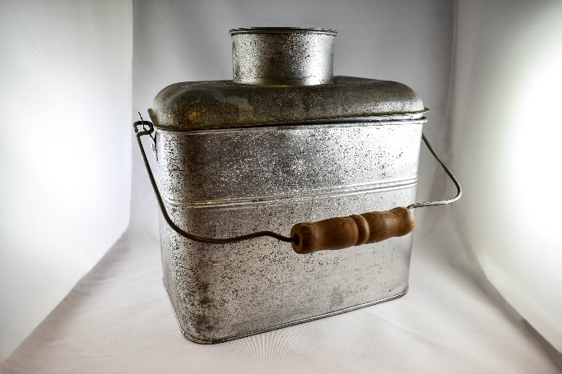
Miners Lunchbox
Metal lunch pails became popular in the 19th century. They were especially useful to miners in order to keep toxic dust away from their food. The lunchbox you see here has a lift out section for coffee or soup, complete with a removable cup, and a small tray that could function as a plate.

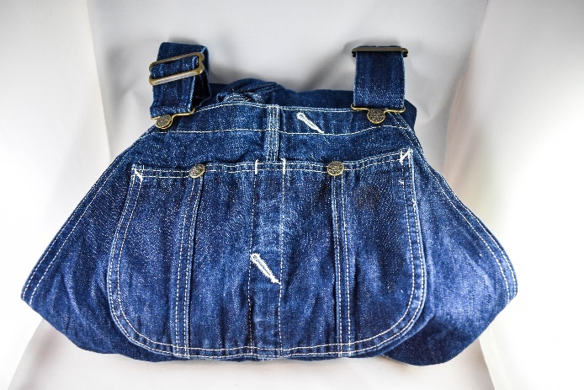
Denim Overalls
In 1853, Levi Strauss saw the need for tough miners clothing, and developed the first pair of denim pants from a piece of tent canvas. The trousers were tough enough for miners, and gained a reputation for lasting a long time, even in the harsh conditions of mining.

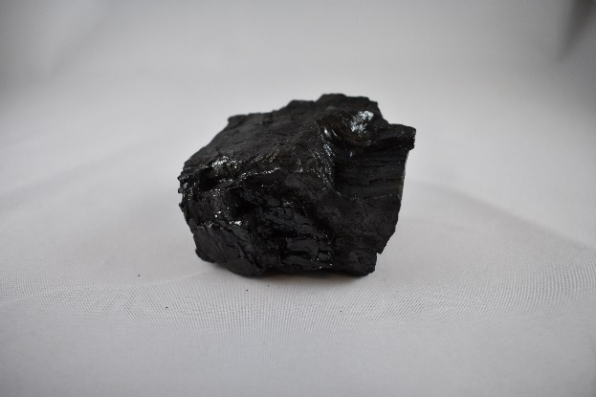
Piece of Coal
Coal is one of the three ingredients necessary to make iron. It just so happens that Central Alabama has a large supply of coal, which helped spur the Birmingham iron industry. Coal in its natural state has too many impurities to be used in the iron making process, so it is heated up and processed in coke ovens until it turns a dull, gray color. When in this state, it is able to burn at a hotter temperature, and can then be used to melt iron ore, and limestone, in furnaces.

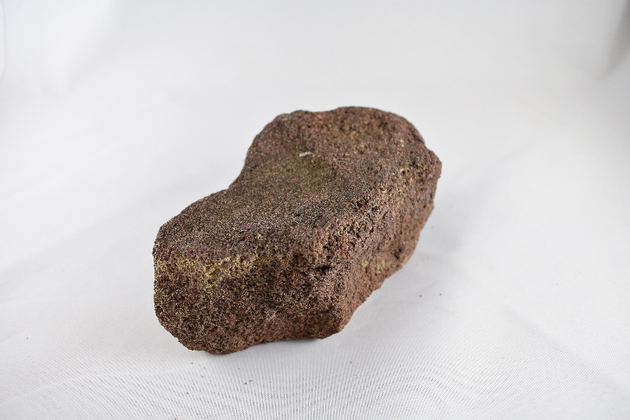
Piece of Iron Ore
Red iron ore, or hematite, is Alabama’s official mineral. It is what gives the soil it’s reddish brown color. Plentiful in the Birmingham area, iron ore is used to create pig iron, which is used to make many types of material goods. Since 1870, an estimated 300 million tons of iron ore has been extracted from area mines.

Suggested Activities
Introduction to Objects:
Pre Class Assignment: Have students bring in an object (not a picture) from home that describes them/their life. On day of activity: Divide students into small groups and distribute objects among groups. Instruct students to pass the objects around, and come up with a story explaining what the object was used for and information about the life of its owner. One group member should write out the story in paragraph form. As a follow up, have students claim their objects, and tell the class how they represent their lives. Finally, the teacher should facilitate a discussion about how historical objects can help tell the stories of people from the past. This activity is important because it helps students make a personal connection to the study of history, helping them understand how historical study is relevant.
Object Analysis:
Divide students into small groups and distribute one object from the trunk to each group. Instruct students to discuss the object as a group, but answer the following questions individually: What are you looking at? How does the object feel? What color(s) is/are the object? What is the object made of? How was the object made? What resources would be necessary to make this object? What was the intended function of this object? Where was the object used? Who used the object? What can we learn about early industrial history from this object? Draw a picture of the object. The teacher may create a graphic organizer with the questions and distribute copies to students, or can project the questions at the front of classroom and have students use their own paper. After allowing enough time for analysis, have students present their objects, describing each to the class. This activity is important because it helps students to learn tactilely, helping include tactile learners while developing critical thinking skills.
Story Telling with Objects
This can be a small group or whole class activity. Divide trunk objects and photos by use: mining, iron/steel production, etc. After completing an object analysis, instruct students to write a journal entry or letter describing the life of someone who used the objects, essentially telling a story based on what they have learned through their object study. Length of the assignment is up to teacher. This activity is important because it requires students to use critical thinking and imagine life from a different perspective, eliciting historical empathy.
If I Could Talk
If an object could talk, what would it say? Instruct students to write a short story or poem from the perspective of the object. E.g., what has it seen, done, etc? How does it feel? Length of assignment is up to teacher. This activity is important because it forces students to see a situation from a differing perspective, eliciting historical empathy.
Commonality of Objects:
The students will enter the classroom and sit on the floor. There will be several items from the trunk displayed in the front of the classroom. These objects may include a miner’s helmet, miner’s lunch pail, a head lamp, etc. Have the children answer the following question, “What do these items have in common?” While they are answering the question, have the students pass around the items and examine them closely. They will write down their responses to the question on a sheet of paper or in their bell ringer notebook. Following this, the teacher will facilitate a student led discussion and explain what each item is and what it was used for. This is important because it allows students to gain new learning insight from their peers.
Photo Analysis:
In this segment students will use primary source photographs that they will examine closely in an activity called, “crop it”. The teacher will break the classroom into collaborative learning groups consisting of three to four members per group depending on the classroom size. Each group will be given several photographs from the trunk and/or digital packet that they will “crop” or analyze closely. The teacher should provide students with 2 popsicle sticks each, which they will use to “crop” the photos, or focus in on a small portion of the photo. Students will be given a graphic organizer (from digital packet) where they will be asked to note details to determine the main events taking place in the photographs, and support their answers by providing key details. This activity is important because it helps student develop their analysis skills while learning about local history.
What Do You Think? – Bellringer
Display a picture of Sloss Furnaces in downtown Birmingham during the time when it was fully operational (In digital packet). There will be two questions written on the board that the students will answer, “What do you think it was like to work here?” “Would you like to work there? – Why or why not?” Have students answer the questions on a sheet of paper or in their bell ringer notebook. Once they have had a few minutes to come up with ideas, facilitate a group discussion. If students give a one or two word answer, ask them to elaborate. This activity is important because it helps students to visualize life from the time period, and also forces them to contemplate how they would feel in the same situation, eliciting empathy.
Listen Closely:
The teacher will turn the lights off (teacher preference depending on class ability) and begin playing an audio file containing sounds of an operational blast furnace https://www.youtube.com/watch?v=rTLY56N9ku0. Ask the students to recall their bell ringer questions (“What Would You Think” activity above). Next, show the students some pictures of the blast furnaces at Sloss and images of the surrounding property such as the company towns (in digital packet). Let the students visualize what the scenery and sounds of the blast furnace would have looked like back then. Ask the students to discuss the feelings and emotions they experienced during the activity. This activity is useful because it elicits historical empathy, as students must put themselves in the shoes of workers in a dangerous environment.

Perspective Writing:
In this activity, students will take on the perspective of a worker or family member living and working at Sloss Furnaces. The students will be asked to use their own paper to complete this activity. Length of writing is up to teacher in accordance with time available. The students will be asked to write either a letter to a family member or a journal entry from the perspective of either a Sloss worker or a family member living in the company housing, describing their life either at work, or at home, or both. This activity will count as their assessment for the lesson. The students should be able to take the information they gained during the lesson and summarize the main ideas to create a response from their character’s point of view. This activity is useful because it elicits historical empathy while forcing students to use critical thinking skills.

Immigration Storyboard:
Distribute storyboard graphic organizer from digital packet and instruct students to use colored pencils or crayons to both write and illustrate a short story explaining why someone would want to leave their home country and move to Birmingham, imagining how that person feels about this big life change. Are they excited, scared, missing home, ready to start working at their new job? Etc. This activity is important because it elicits historical empathy.

Act it Out
This activity should be completed toward the end of your study so that students have plenty of background information. Gather students in a circle, and pass out the wearable objects from the trunk (hats, overalls, headlamp), they can also utilize the lunch pail and other objects as the teacher sees appropriate. Instruct students to act out a scene from the perspective of the person who would have worn that object (coal miner, factory worker, etc.) Continue to pass around the objects until all students have had the opportunity to complete the activity. This activity is important because it gives students the opportunity to learn from their peers, and elicits critical thinking skills, while having fun with history.

Standards
Depending on how the teacher structures her/his lesson plans, it is possible to meet all of the standards below by utilizing the Traveling Trunk
Kindergarten
ACOS | CCRS
Social Studies | Reading Informational Text
2. Compare families of today with families of the past in relation to work, home, and school. | CCSS.ELA-LITERACY.CCRA.R.7  Integrate and evaluate content presented in diverse media and formats, including visually and quantitatively, as well as in words.¹
3. Identify historically significant events as they relate to self and family.
Language Arts
10. Use print and nonprint classroom, library, and real-world resources to acquire information.
Visual Arts
6. Identify artistic characteristics of cultures, times, and places.

1st Grade
ACOS | CCRS
Social Studies | Reading Informational Text
4. Describe the role of money in everyday life. | CCSS.ELA-LITERACY.RI.1.1  Ask and answer questions about key details in a text.
5. Label human-made and natural resources in Alabama. | CCSS.ELA-LITERACY.RI.1.4  Ask and answer questions to help determine or clarify the meaning of words and phrases in a text.
8. Identify how occupational and recreational opportunities in Alabama and local communities are affected by the physical environment.
Science
2. Identify basic properties of objects.
7. Identify components of Earth’s surface, including soil, rocks, and water.
Language Arts
12. Collect information from print and nonprint resources to investigate a teacher- or student selected topic.
Visual Arts
4. Recognize similarities and differences in media, visual and tactile characteristics, and natural or man-made forms used in artwork.
6. Recognize artistic characteristics of various cultures, times, and places.
2nd Grade
ACOS | CCRS
Social Studies | Reading Informational Text
1. Compare features of modern-day living to those of the past. | CCSS.ELA-LITERACY.RI.2.1  Ask and answer such questions as who, what, where, when, why, and how to demonstrate understanding of key details in a text.
2. Identify past and present contributions of a variety of individuals who have overcome difficulties or obstacles to achieve goals. | CCSS.ELA-LITERACY.RI.2.3  Describe the connection between a series of historical events, scientific ideas or concepts, or steps in technical procedures in a text.
3. Discuss historical and current events within the state and the nation that are recorded in a variety of resources.
5. Explain the relationship between the production and distribution processes.
6. Identify human-made and natural resources in the world.
7. Describe ways people throughout the world are affected by their geographic environments.
11. Explain how the diversity of people and customs in the United States and the world affect viewpoints and ideas.
Science
7. Identify geological features as mountains, valleys, plains, deserts, lakes, rivers, and oceans.
8. Identify evidence of erosion and weathering of rocks.
Language Arts
12. Utilize research skills to collect and record information on a specific topic.

3rd Grade
ACOS | CCRS
Social Studies | Reading Informational Text
2. Describe physical characteristics, including landforms, bodies of water, soil, and vegetation of various places on Earth. | CCSS.ELA-LITERACY.RI.3.3  Describe the relationship between a series of historical events, scientific ideas or concepts, or steps in technical procedures in a text, using language that pertains to time, sequence, and cause/effect.
5. Identify national and international trading patterns of the United States. | CCSS.ELA-LITERACY.RI.3.4  Determine the meaning of general academic and domain-specific words and phrases in a text relevant to a grade 3 topic or subject area.
7. Describe the relationship between locations of resources and patterns of population distribution in the Western Hemisphere. | CCSS.ELA-LITERACY.RI.3.7  Use information gained from illustrations (e.g., maps, photographs) and the words in a text to demonstrate understanding of the text (e.g., where, when, why, and how key events occur).
8. Identify geographic links of land regions, river systems, and interstate highways between Alabama and other states.
11. Identify significant historical sites in Alabama, including locations of civil rights activities.
Science
2. Identify physical and chemical changes of matter.
Language Arts
8. Use text features to guide interpretation of expository texts, including italics, headings, maps, and charts.
12. Demonstrate retrieval skills needed to research a topic.

4th Grade
ACOS | CCRS
Social Studies | Reading Informational Text
1. Identify historical and current economic, political, and geographic information about Alabama on thematic maps. | CCSS.ELA-LITERACY.RI.4.3  Explain events, procedures, ideas, or concepts in a historical, scientific, or technical text, including what happened and why, based on specific information in the text.
2. Describe cultures, governments, and economies of prehistoric and historic Native Americans in Alabama. | CCSS.ELA-LITERACY.RI.4.4  Determine the meaning of general academic and domain-specific words or phrases in a text relevant to a grade 4 topic or subject area.
3. List reasons for European exploration and settlement in Alabama and the impact of Europeans on trade, health, land expansion, and tribal reorganization of Native American populations in Alabama. | CCSS.ELA-LITERACY.RI.4.7  Interpret information presented visually, orally, or quantitatively (e.g., in charts, graphs, diagrams, time lines, animations, or interactive elements on Web pages) and explain how the information contributes to an understanding of the text in which it appears.
4. Describe the relationship of the five geographic regions of Alabama to the movement of Alabama settlers during the early nineteenth century.
6. Describe cultural, economic, and political aspects of the life styles of early 19th century farmers, plantation owners, slaves, and towns people.
8. Explain Alabama’s role in and economic support of the Civil War.
9. Describe political, social, and economic conditions in Alabama during Reconstruction.
10. Analyze social and educational changes during the late 19th to early 20th centuries for their impact on Alabama.
16. Describe the impact of population growth on cities, major road systems, demographics, natural resources, and the natural environment of Alabama during the twentieth century.
Science
7. Describe geological features of Earth, including bodies of water, beaches, ocean ridges, continental shelves, plateaus, faults, canyons, sand dunes, and ice caps.
Language Arts
5. Use a wide range of strategies and skills, including using sentence structure, locating information, and distinguishing fact from fiction, to comprehend fourth-grade informational and functional reading materials.
12. Organize information on a specific topic obtained from grade-appropriate reference materials.

5th Grade
ACOS | CCRS
Social Studies | Reading Informational Text
1. Locate physical features that impacted the exploration and settlement of the Americas. | CCSS.ELA-LITERACY.RI.5.1  Quote accurately from a text when explaining what the text says explicitly and when drawing inferences from the text.
2. Identify causes and effects of prehistoric migration and settlement in North America. | CCSS.ELA-LITERACY.RI.5.4  Determine the meaning of general academic and domain-specific words and phrases in a text relevant to a grade 5 topic or subject area.
10. Describe political, social, and economic events between 1803 and 1860 that led to the expansion of the territory of the United States. | CCSS.ELA-LITERACY.RI.5.7  Draw on information from multiple print or digital sources, demonstrating the ability to locate an answer to a question quickly or to solve a problem efficiently.
13. Identify social, political, and economic changes that occurred during Reconstruction.

6th Grade
ACOS | CCRS
Social Studies | Reading Informational Text
1. Describe the Westward Expansion and its technological, economic, and social influence on the people of the United States prior to World War I. | CCSS.ELA-LITERACY.RI.6.3  Analyze in detail how a key individual, event, or idea is introduced, illustrated, and elaborated in a text (e.g., through examples or anecdotes).
2. Describe the impact of industrialization, free markets, urbanization, communication, and cultural changes in the United States prior to World War I. | CCSS.ELA-LITERACY.RI.6.4  Determine the meaning of words and phrases as they are used in a text, including figurative, connotative, and technical meanings.
4. Describe changing social conditions during the Progressive Period. | CCSS.ELA-LITERACY.RI.6.7  Integrate information presented in different media or formats (e.g., visually, quantitatively) as well as in words to develop a coherent understanding of a topic or issue.
5. Explain causes and effects of the Great Depression on the people of the United States
9. Critique major social and cultural changes in the United States since World War II.
11. Identify technological advancements on society in the United States since World War II.
Language Arts
14. Use organizing and paraphrasing in the research process.

7th Grade
ACOS | CCRS
Social Studies - Citizenship | Reading Informational Text
11. Compare changes in social and economic conditions in the United States during the 20th and 21st centuries. | CCSS.ELA-LITERACY.RI.7.1  Cite several pieces of textual evidence to support analysis of what the text says explicitly as well as inferences drawn from the text.
Social Studies - Geography | CCSS.ELA-LITERACY.RI.7.4  Determine the meaning of words and phrases as they are used in a text, including figurative, connotative, and technical meanings; analyze the impact of a specific word choice on meaning and tone.
1. Describe the world in spatial terms using maps, major physical and human features, and urban and rural land-use patterns.
4. Evaluate spatial patterns and the demographic structure of population on Earth’s surface in terms of density, dispersion, growth and mortality rates, natural increase, and doubling time.
10. Explain how human systems develop in response to physical environment conditions.
11. Compare the distribution of natural resources in various parts of the world by mapping locations of major deposits.
Language Arts
13. Apply steps in the research process to identify a problem or issue, locate resources and information, and present findings.
15. Demonstrate listening skills, including identifying the main idea, detail, purpose, and bias in group
discussions, public speeches, and media messages.

8th Grade
ACOS | CCRS
 | Reading Informational Text
CCSS.ELA-LITERACY.RI.8.3
Analyze how a text makes connections among and distinctions between individuals, ideas, or events (e.g., through comparisons, analogies, or categories).

CCSS.ELA-LITERACY.RI.8.4
Determine the meaning of words and phrases as they are used in a text, including figurative, connotative, and technical meanings; analyze the impact of specific word choices on meaning and tone, including analogies or allusions to other texts.

9th Grade
ACOS | CCRS
Social Studies | Reading Informational Text
10. Describe the influence of urbanization during the nineteenth century on the Western World. | CCSS.ELA-LITERACY.RI.9-10.1  Cite strong and thorough textual evidence to support analysis of what the text says explicitly as well as inferences drawn from the text.
13. Explain challenges of the post-World War I period. | CCSS.ELA-LITERACY.RI.9-10.4  Determine the meaning of words and phrases as they are used in a text, including figurative, connotative, and technical meanings; analyze the cumulative impact of specific word choices on meaning and tone (e.g., how the language of a court opinion differs from that of a newspaper).
Language Arts | CCSS.ELA-LITERACY.RI.9-10.7  Analyze various accounts of a subject told in different mediums (e.g., a person's life story in both print and multimedia), determining which details are emphasized in each account.
13. Demonstrate paraphrasing, quoting, and summarizing of primary and secondary sources and various methods of note taking.
14. Use the research process to locate, select, retrieve, evaluate, and organize information to support a thesis on a nonliterary topic.
15. Identify persuasive strategies in oral and visual presentations.
17. Use supporting details to present a position and to respond to an argument.

10th Grade
ACOS | CCRS
Social Studies | Reading Informational Text
2. Compare regional differences among early New England, Middle, and Southern colonies regarding economics, geography, culture, government, and American Indian relations. | CCSS.ELA-LITERACY.RI.9-10.1  Cite strong and thorough textual evidence to support analysis of what the text says explicitly as well as inferences drawn from the text.
16. Explain the transition of the United States from an agrarian society to an industrial nation prior to World War I. | CCSS.ELA-LITERACY.RI.9-10.4  Determine the meaning of words and phrases as they are used in a text, including figurative, connotative, and technical meanings; analyze the cumulative impact of specific word choices on meaning and tone (e.g., how the language of a court opinion differs from that of a newspaper).
Language Arts | CCSS.ELA-LITERACY.RI.9-10.7  Analyze various accounts of a subject told in different mediums (e.g., a person's life story in both print and multimedia), determining which details are emphasized in each account.
15. Use the research process to document and organize information to support a thesis on a literary or nonliterary topic.

11th Grade
ACOS | CCRS
Social Studies | Reading Informational Text
1. Explain the transition of the United States from an agrarian society to an industrial nation prior to World War I | CCSS.ELA-LITERACY.RI.11-12.3  Analyze a complex set of ideas or sequence of events and explain how specific individuals, ideas, or events interact and develop over the course of the text.
2. Evaluate social and political origins, accomplishments, and limitations of Progressivism. | CCSS.ELA-LITERACY.RI.11-12.4  Determine the meaning of words and phrases as they are used in a text, including figurative, connotative, and technical meanings; analyze how an author uses and refines the meaning of a key term or terms over the course of a text (e.g., how Madison defines faction in Federalist No. 10).
5. Evaluate the impact of social changes and the influence of key figures in the United States from World War I through the 1920s, including Prohibition, the passage of the Nineteenth Amendment, the Scopes Trial, immigration, the Red Scare, Susan B. Anthony, Margaret Sanger, Elizabeth Cady Stanton, the Harlem Renaissance, the Great Migration, W. C. Handy, the Jazz Age, and Zelda Fitzgerald. | CCSS.ELA-LITERACY.RI.11-12.7  Integrate and evaluate multiple sources of information presented in different media or formats (e.g., visually, quantitatively) as well as in words in order to address a question or solve a problem.
6. Describe social and economic conditions from the 1920s through the Great Depression, factors leading to a deepening crisis. Including the collapse of the farming economy and stock market crash of 1929.
10. Describe the impact of World War II on the lives of American citizens, including wartime economic measures, population shifts, growth in the middle class, growth of industrialization, advancements in science and technology, increased wealth in the African-American community, racial and ethnic tensions, Servicemen’s Readjustment Act of 1944, and desegregation of the military.
Language Arts
12. Use the research process to manage, document, organize, and present information to support a thesis on a literary topic.
13. Compare the use of oral presentation skills of self and others.

12th Grade
ACOS | CCRS
Social Studies - Economics | Reading Informational Text
3. Describe different economic systems used to allocate scarce goods and services. | CCSS.ELA-LITERACY.RI.11-12.3  Analyze a complex set of ideas or sequence of events and explain how specific individuals, ideas, or events interact and develop over the course of the text.
8. Explain the impact of the labor market on the United States economy. | CCSS.ELA-LITERACY.RI.11-12.4  Determine the meaning of words and phrases as they are used in a text, including figurative, connotative, and technical meanings; analyze how an author uses and refines the meaning of a key term or terms over the course of a text (e.g., how Madison defines faction in Federalist No. 10).
Language Arts | CCSS.ELA-LITERACY.RI.11-12.7  Integrate and evaluate multiple sources of information presented in different media or formats (e.g., visually, quantitatively) as well as in words in order to address a question or solve a problem.
10. Use the research process to manage, document, organize, and present information to support a thesis on a teacher-approved topic of student interest.
12. Evaluate oral presentation skills of self and others for effectiveness.
Additional Resources for Teachers:

Links with additional historical background for teacher:

Digital Archives of Maps Detailing Geology of Alabama – University of Alabama: http://alabamamaps.ua.edu/historicalmaps/geology/index1900.html http://alabamamaps.ua.edu/historicalmaps/geology/index1900-1925.html http://alabamamaps.ua.edu/historicalmaps/geology/index1926-1950.html

Digital Cartography Archives of Jefferson County, AL – University of Alabama
http://alabamamaps.ua.edu/historicalmaps/counties/jefferson/jefferson.html

Digital Cartography Collection – Birmingham Public Library: http://bplonline.cdmhost.com/digital/collection/p4017coll7/search/searchterm/alabama%20--%20maps/field/subjec/mode/exact/conn/and/order/title/ad/asc/page/6

